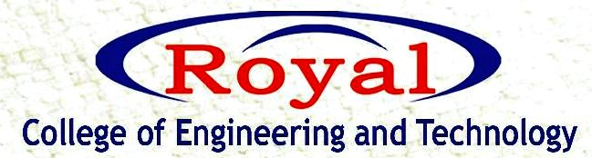
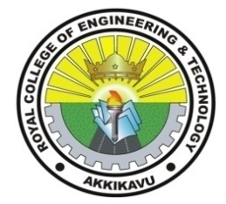
IEDC
“MEET THE FOUNDER”
WEBINAR

RCET IEDC organized an online webinar on the topic “How to be an Entrepreneur?” for the students on October 24th, 2021 through Google meet. The keynote speaker was Mr. Suhas P S, Spillspark The Finishing School Pvt Ltd, Kollam, and Trivandrum. Almost 80 students took part in the session. Registration link was provided to the students to register for the event.
The session started by 11.05 am with a silent prayer .The welcome speech was given by Mrs. Neethu Assistant professor, Computer science department .She thanked the guest for making time for this session and also informed the students about the time when Idec was active during Suhas sirs teaching period. The session by Mr. Suhas P S was quite active and interesting.The session was very interactive and there was good cooperation and response from the students.
Our respected principal Dr.Devi V M thanked the guest as well as the whole IEDC team for arranging this session. The program concluded with a vote of thanks. Feedback link was provided in the chat box and based on that E-certificates are provided to all the students who attended the session.
